ESP-7-64-764B

Ni-MH BUTTON CELL
TECHNICAL DATA

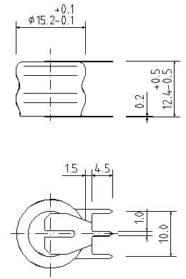

Model | Voltage | Capacity | Recommended Trickle Charge Current | Nominal Charge Current | Normal Charging Time | Nominal Discharge Current | Weight
ESP-7-64-764B | 2.4V | 80mAh | 2.4~4mA | 8mA | 14~16h | 16Ma | 8g

TECHNICAL CHARACTERISTICS
TYPICAL CHARGE CURVE ( 8mA ) |  | TYPICAL DISCHARGE CURVE ( 16mA ) |  | CYCLE LIFE CURVE
VOLTAGE (V) | 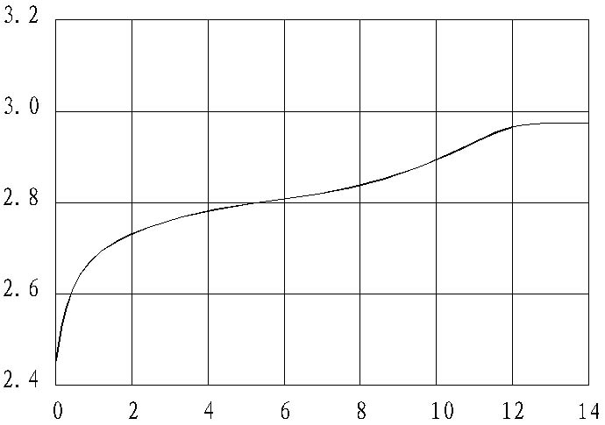 | VOLTAGE (V) | 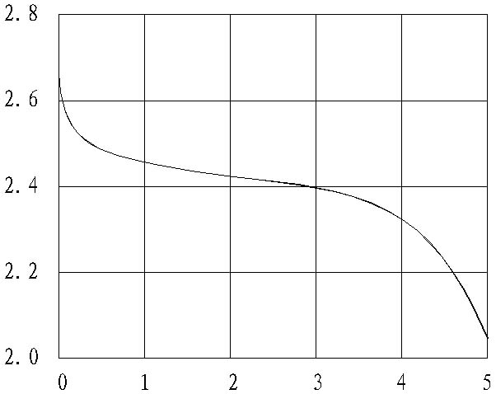 | % NOMINAL CAPACITY | 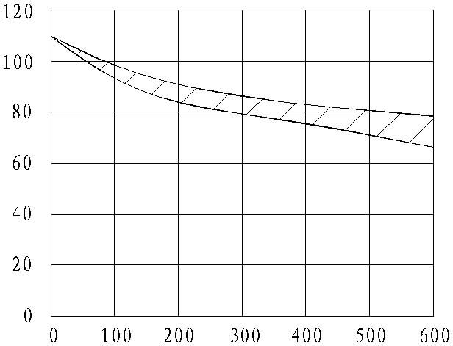
VOLTAGE (V) | Time：( H ) | VOLTAGE (V) | Time：( H ) | % NOMINAL CAPACITY | Number of cycles
TYPICAL CHARGE CURVE AT VARIOUS CURRENTS |  | DISCHARGE CURVE AT VARIOUS TEMPERATURES (16mA) |  | SELF DISCHARGE RATE AT VARIOUS TEMPERATURES
VOLTAGE (V) | 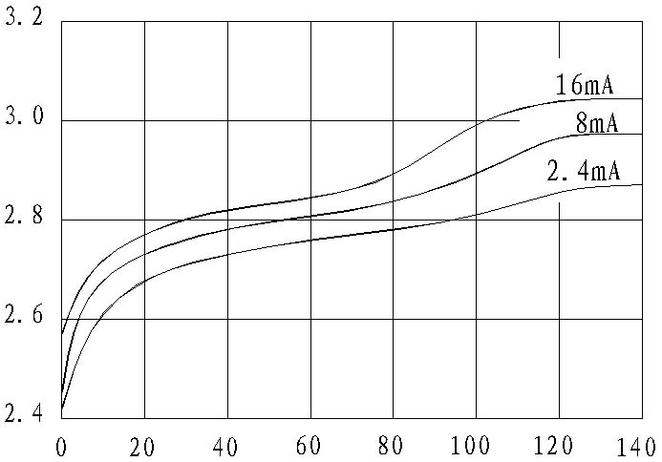 | VOLTAGE (V) | 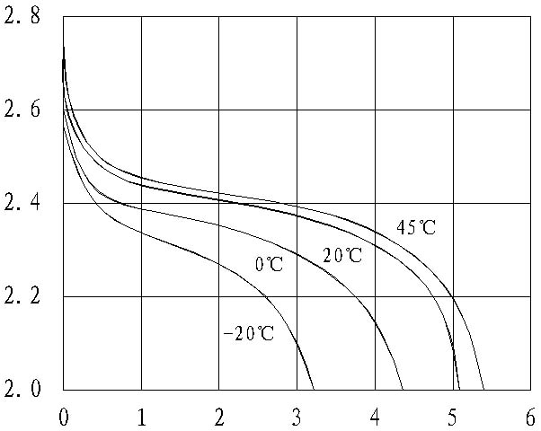 | RETAINED CAPACITY (%) | 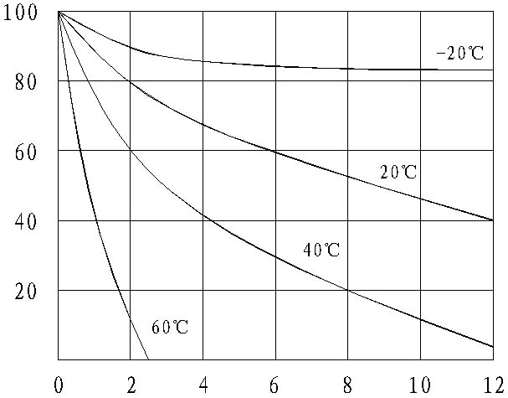
VOLTAGE (V) | Capacity input (%) | VOLTAGE (V) | Time：(H) | RETAINED CAPACITY (%) | Time：(Months)

