Battery Model： ESP2500AFH |  |  |  |  | DATASHEET
Nominal voltage（V） |  |  |  | 1.2 | 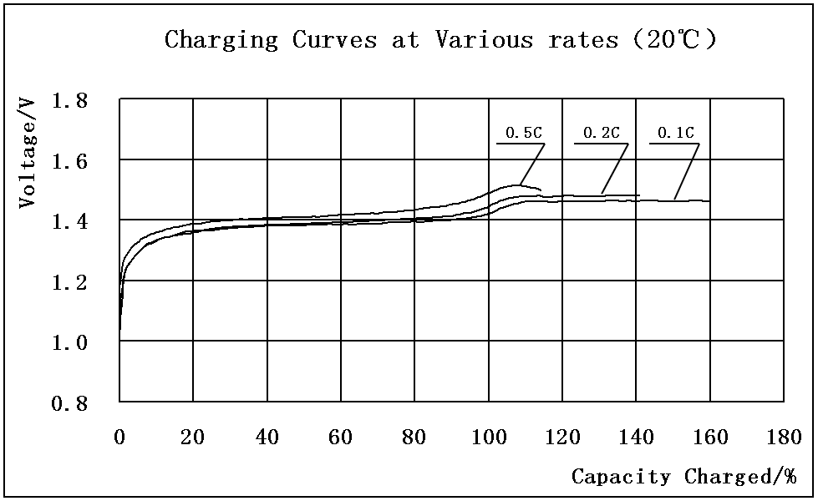  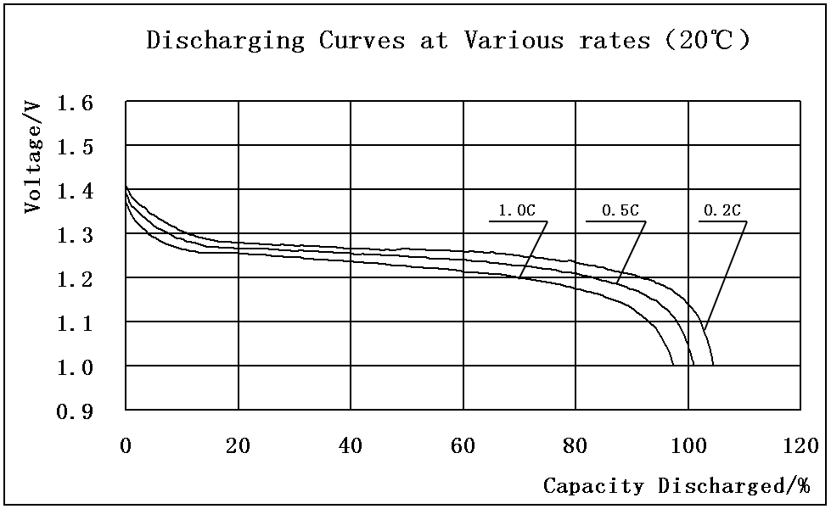  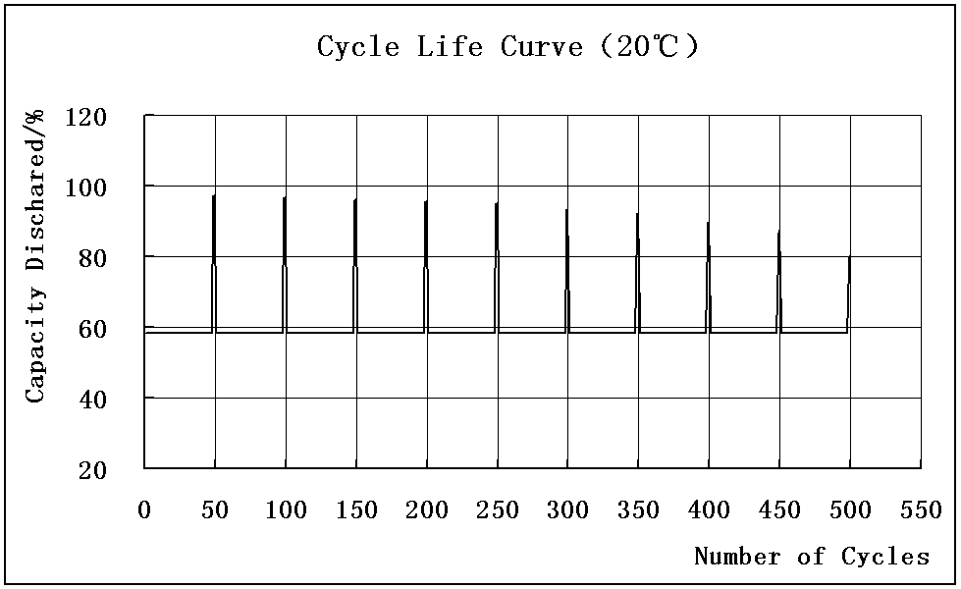  Note:  *: Discharge capacity when the battery unit is discharged at 500mA to the 1.0V end voltage after being charged at 250mA for 16 hours  **: Please discharge to the 1.0V end voltage with500mA before charging the battery unit.
Capacity*  （mAh） |  | Nominal |  | 2500
 |  | Minimum |  | 2500
Charging** |  | Standard |  | 250mA×16hours
 |  | Quick |  | 500mA×7hours
 |  | Rapid |  | 1250mA×2.4hours _{-△V=5mV}
 |  | Trickle |  | 75mA~125mA
Temperature  recommended  （℃） |  | Standard charge |  | 0~40
 |  | Quick charge |  | 10~40
 |  | Rapid charge |  | 10~30
 |  | Discharge |  | -20~60
 |  | Storage |  | -20~30
Internal resistance |  |  |  | ≤20mΩ
End voltage of discharge |  |  |  | 1.0V
Charge (capacity) retention |  |  |  | ≥60%
Weight |  |  |  | Approx. 32g
Dimensions  With tube  （mm） | D |  | Diameter | 17.0+0 -0.7
Dimensions  With tube  （mm） | H |  | Height | 50.0+0.5 -0.2
Dimensions  With tube  （mm） | a |  | Top diameter | 8.0+0.1 -0.1
Drawing | 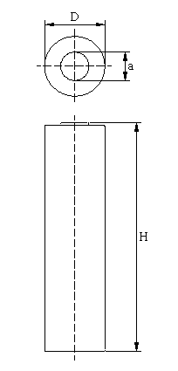

SPECIFICATION

Product Type : Ni-MH Rechargeable Battery
Model No : ESP2500AFH 2500mAh 1.2V

2.NOMINAL SPECIFICATION
2-1.Nominal voltage | 1.2V
2-2.Nominal capacity* | 2500mAh
2-3.Minimum capacity* | 2500mAh
2-4.Charging**
Standard charging | 250mA for 16 hours
Quick charging | 500mA for 7 hours
Rapid charging | 1250mA for 2.4hours, –ΔV=5mV
Trickle charging | 75mA ~125mA
2-5.End voltage of discharge | 1.0V
2-6.Temperature (recommended)
Standard charge | 0~40℃
Quick charge | 10~40℃
Rapid charge | 10~30℃
Discharge: | -20~60℃
Storage: Less than 30 days | -20~50℃
Less than 90 days | -20~40℃
Less than 1 year | -20~30℃
2-7.Relative humidity | 45~85%
2-8.Weight | Approx. 32g
2-9.Dimensions | shown in the page 5
Note *: Discharge capacity when the battery unit is discharged at 500mA after being standard charged.
**: Unless otherwise stated in these specifications, the battery unit should be discharged to 1.0V end voltage with 500mA before charging.

3. APPEARANCE
There shall be no practical damage such as conspicuous liquid electrolyte leakage, flow and dirt under conditions of storage or operation as specified herein.

4.ELECTRICAL CHARACTERISTICS
4-1.Testing conditions
The battery shall be evaluated within 1 month from the arrival date.
Unless otherwise stated in these specifications, the following test shall be carried out in an ambient temperature of 20±5℃, relative humidity of 65±20%.
4-2.Terminal voltage (O.C.V)
Open circuit voltage shall be a minimum voltage of 1.250V within 14 days after being standard charged
4-3. Internal resistance
Within 1 hour after being standard charged, the internal resistance is not greater than 20mΩ,as tested by 1000Hz AC source.
4-4.Capacity
4-4-1.The battery unit shall be capable of supplying 500mA continuous discharge current for a minimum of 300 minutes to the 1.0V end voltage within 1 hour after being standard charged.
4-4-2.The battery unit shall be capable of supplying 1250mA continuous discharge current for a minimum of 110 minutes to the 1.0V end voltage within 1 hour after being standard charged.
4-4-3.The battery unit shall be capable of supplying 2500mA continuous discharge current for a minimum of 52 minutes to the 1.0V end voltage within 1 hour after being standard charged.
4-5.Temperature characteristics
4-5-1.Within 1 hour after being standard charged at 40℃, the battery unit shall be discharged at 20℃, at a current of 500mA to 1.0V end voltage, discharge time shall be a minimum of 180 minutes.
4-5-2. Within 1 hour after being standard charged at 20℃, the battery unit shall be discharged at 0℃, at a current of 500mA to 1.0V end voltage, discharge time shall be a minimum of 180 minutes.
4-6.Charge (capacity) retention
After being standard charged battery unit is stored for 28 days at 20±2℃, the battery unit shall be discharged at 20℃, at a current of 500mA to 1.0V end voltage, discharge time shall be a minimum of 180 minutes.
4-7.Overcharge
Within 1 hour after being charged at a current of 250mA for 48 hours, the battery unit shall be discharged at 20℃, at a current of 500mA to 1.0V end voltage, discharge time shall be a minimum of 300 minutes.
4-8.Endurance in cycles
Prior to the endurance in cycles test, the battery unit shall be discharged at 500mA to 1.0V end voltage. A battery unit shall be capable of 500 minimum cycles under the conditions as follows.
Cycle | Charge | Rest | Discharge
1 | 0.1CmA for 16hours | None | 0.25CmA×140minutes
2~48 | 0.25CmA for 190minutes | None | 0.25CmA×140minutes
49 | 0.25CmA for 190minutes | None | 0.25CmA to 1.0V
50 | 0.1CmA for 16hours | 1h to 4h | 0.2CmA to 1.0V
Cycles 1 to 50 shall be repeated until the discharge time on any 50th cycle becomes less than 3 hours. At this stage, repeat 50th cycle, if the discharge time is less than 3 hours again the test is terminated.
Note: If battery unit voltage drops below 1.0V, discharge shall be discontinued.

4-9.Safety
4-9-1.Continuous low-rate charging
The battery unit shall not explode when it is charged at 75mA~125mA for 28 days. However, it is acceptable for the battery unit to sustain leakage of battery fluid and show a change in appearance.
4-9-2.Forced discharge
The battery unit shall not explode when it is reverse-charged at 2500mA for 1 hour after being discharged at 500mA to 1.0V end voltage. However, it is acceptable for the battery unit to sustain leakage of battery fluid and show a change in appearance.
4-10.Vibration
The battery unit shall not show a change in appearance, leak or explode, when it is tested under the following conditions After being standard charged
Frequency | 10~55Hz
Amplitude | 0.76mm
Rate of frequency variety | 1 Hz/minute
Duration | 90 minutes /axis (axis: X、Y、Z) 270 minutes in all

5.PRECAUTION:
Please keep in mind the following points when designing and manufacturing equipment. Please insert in your instruction manual. To prevent equipment malfunctions from affecting the batteries, be sure to use protection devices for electrical circuits and batteries.
Danger!
● | Failure to carefully observe the following procedures and precautions can result in leakage of battery fluid (electrolyte), heat generation, explosion, fire and serious personal injury!
· | Never dispose of batteries in a fire or heat them.
· | Do not connect the (+) positive and (-) negative terminals of batteries together with electrically conductive materials, including lead wires. Do not transport or store batteries with their uncovered terminals or connected with a metal necklace or other electrically conductive material. When carrying or storing batteries, use a special case.
· | Only charge batteries using those specific chargers that satisfy specifications. Only charge batteries under the conditions specified.
· | Never disassemble batteries. Doing so may cause an internal or external short circuit or result in exposed material of battery reacting chemically with the air. It may also cause heat generation, explosion and fire. Also, this is dangerous as it may cause splashing of alkaline fluid
· | Never solder lead wires directly on to batteries.
· | The (+) positive and (-) negative terminals of batteries are predetermined. Do not force the terminals to connect to a charger or equipment. If the terminals cannot be easily connected to the charger or the equipment, check if the (+) and (-) terminals are incorrectly positioned.
· | The gas release vent which release internal gas is located in the (+) positive terminal of the battery. For this reason, never deform his section or cover or obstruct its gas release structure.
· | Do not directly connect batteries to a direct power source or the cigarette lighter socket in a car.
·
● | Ni-MH batteries contain a strong colorless alkaline solution (electrolyte). The alkaline solution is extremely corrosive and will cause skin damage. If any fluid from a battery comes in contact with user’s eyes, they should immediately flush their eyes and wash them thoroughly with clean water from the tap or another source and consult a doctor urgently. The strong alkaline solution can damage eyes and lead to permanent loss of eyesight.
● | When batteries are to be incorporated in equipment or housed within a case, avoid air-tight structures, as this may lead to the equipment or the case being damaged or may be harmful to users.
Warning!
● | Do not apply water, seawater or other oxidizing reagents to batteries, as this can cause rust and heat generation. If a battery becomes rusted, the gas release vent may no longer operate, and can result in explosion.
● | Do not over-charge batteries by exceeding the predetermined charging period specified by the battery charger’s instructions or indicator. If batteries are not fully charged after the battery charger’s predetermined charging period has clasped, stop the charging process. Prolonged charging may cause leakage of battery fluid, heat generation, and explosion. Be sure to handle recharged batteries carefully as they may be not.
● | ESP batteries contain a strong colorless alkaline solution (electrolyte).If the skin or clothing comes in contact with fluid from a battery; thoroughly wash the area immediately with clean water from the tap or another source. Battery fluid can irritate the skin.
● | Do not connect more than 21 pcs of batteries in series, as this may cause electrical shocks, leakage of battery fluid and heat generation.
● | Do not remove the outer tube from a battery or damage it. Doing so will expose the battery to the risk of a short circuit, and may cause leakage of battery fluid, heat, generation, explosion and fire.
● | If batteries leak fluid, change color, change shape, or change in any other way, do not use them, otherwise they may cause heat generation, explosion and fire.
● | Keep batteries and the equipment using them out of the reach of babies and small children, in order to avoid accidental swallowing of the batteries. In the event the batteries are swallowed, consult a doctor immediately.
● | When the operating time of a battery becomes much shorter than its initial operating time even after recharged, it should be replaced to a new battery as its battery life has ended.
CAUTION!
● | Do not strike or drop batteries.
● | Store batteries out of the reach of babies and small children. When charging or using a battery, do not let babies or small children remove the battery from the charger or the equipment being used.
● | Be sure to charge batteries within a temperature range of 0 to 40 deg C (degrees Celsius)
● | Be sure to use the recommended charging method for batteries read the battery charger’s instruction manual carefully
● | Do not use or store battery at high temperature, such as in strong direct sunlight, in cars during hot weather, or directly in front of a heater. This may cause leakage of battery fluid. It could also impair performance and shorten operating life of batteries
● | Be sure to turn off the equipment after use of batteries, otherwise may result in leakage of battery fluid
● | After removed from equipment, store batteries in a dry place and within the recommended storage temperature range. This will help preserve the batteries’ performance and durability and minimize the possibility of leakage of battery fluid or corrosion. (ESP Special Batteries Ltd recommends the storage temperature range from -20 to +30deg.(for longer service life).
● | To use batteries for the first time after purchase or having not used them for a long period of time, be sure to charge them.
● | After long term storage, there is a possibility that the battery could not be fully charged. In order to fully charge it, please charge and discharge battery for a few times.
● | Do not use old and new batteries mixed together, or batteries at different charge levels. Do not use the battery mixed with a dry cell or other batteries of different capacity, type, or brand name. This may cause leakage of battery fluid and heat generation.
● | If the battery terminals become dirty, clean up them with a soft dry cloth prior to use. Dirt on the terminals can result in poor contact with the equipment, loss of power, or inability to charge.

6. WARRANTY
ESP Special Batteries Ltd will be responsible for replacing the batter against any defects or poor workmanship for six months from the date of shipping.
Any other problems caused by malfunction of the equipment or misuse of the battery are not under this warranty.
Notice: To assure safety, please consult ESP Special Batteries Ltd technical staff for your applications including electrical specifications, mechanical designs, protective devices and any special specification.

