ESP330H Ni-MH BUTTON CELL

TECHNICAL DATA

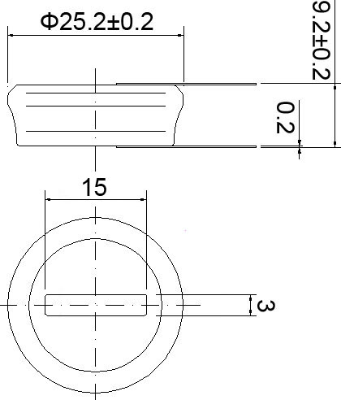

Model | Voltage | Capacity | Recommended  Trickle Charge Current | Nominal  Charge Current | Normal  Charging Time | Nominal  Discharge Current | Weight
ESP330H | 1.2V | 330mAh | 10~16.5mA | 33mA | 14~16h | 66mA | 13.4g

TECHNICAL CHARACTERISTICS
TYPICAL CHARGE CURVE (33mA) |  |  | TYPICAL DISCHARGE CURVE (66mA) |  |  | CYCLE LIFE CURVE
VOLTAGE (V)  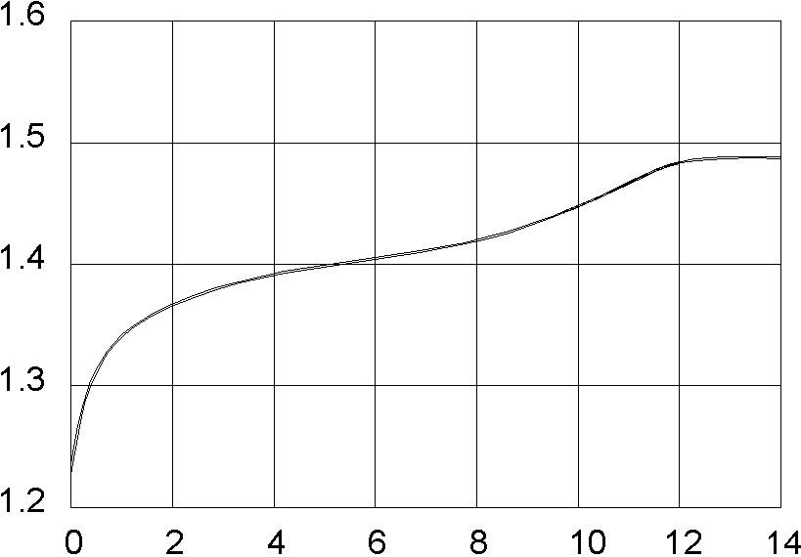 |  |  | VOLTAGE (V)  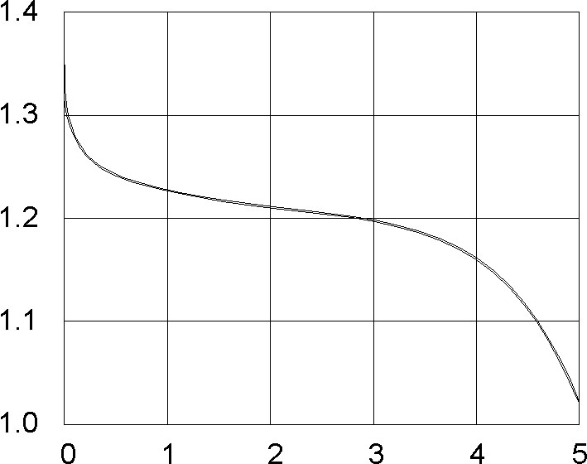 |  |  | % NOMINAL CAPACITY  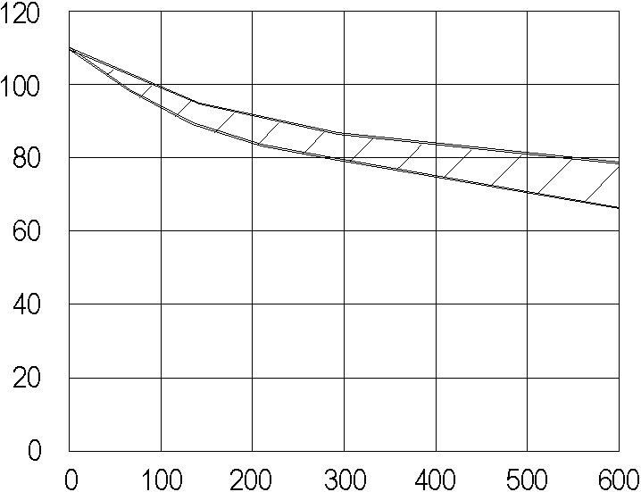
 | Time (H) |  |  | Time (H) |  |  | Number of cycles
TYPICAL CHARGE CURVE AT VARIOUS CURRENTS |  |  | DISCHARGE CURVE AT VARIOUS TEMPERATURES (66mA) |  |  | SELF DISCHARGE RATE AT VAROUS TEMPERATURES
VOLTAGE (V) | 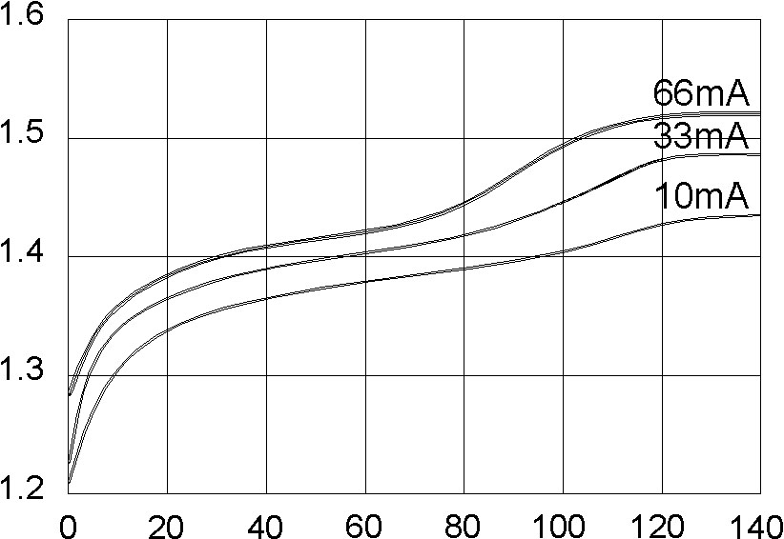 |  | VOLTAGE (V)  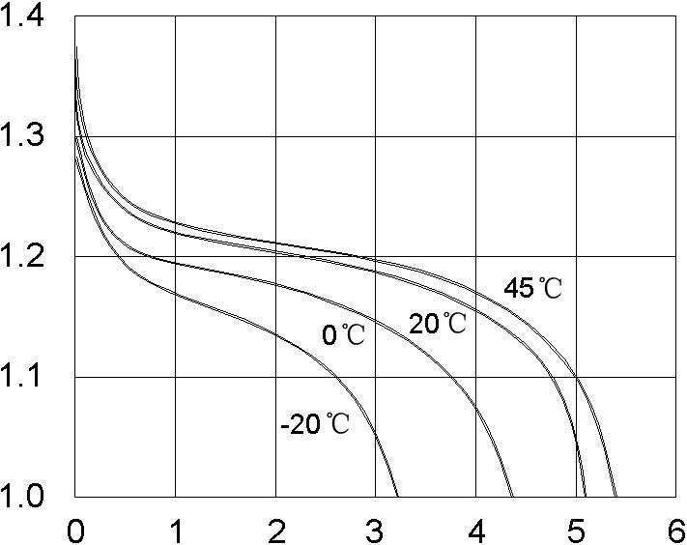 |  |  | RETAINED CAPACITY (%)  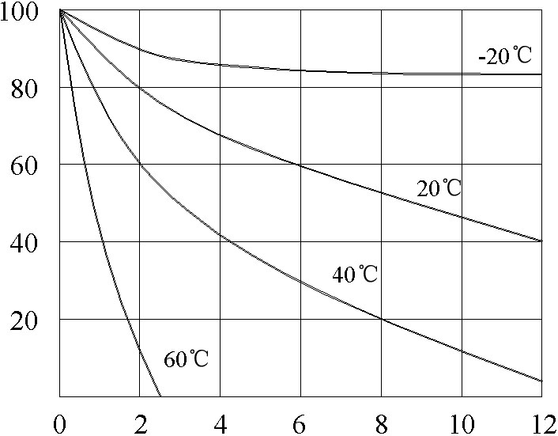
 | Capacity input (%) |  |  | Time (H) |  |  | Time (Months)

TECHNICAL INFORMATION
- APPLICATION
This specification applies to the Ni-MH batteries
Model : ESP330H

- CELL AND TYPE
  - Cell :Sealed Ni-MH Button Cell
  - Type :Button type
  - Size type : 1.2V

- RATINGS
  - Nominal voltage : 1.2V
  - Nominal capacity : 330mAh/0.2CmA
  - Typical weight : 13.4g
  - Standard charge : 33mA×14hours
  - Rapid charge : 66mA×6hours
Trickle current : 9.9mA
  - Discharge cut-off voltage: 1.0V
  - Temperature range for operation (Humidity: Max.85%)
Standard charge 0~+45℃
Rapid charge +10~+45℃
Trickle charge 0~+45℃
Discharge -10~+45℃
3.8 Temperature range for storage (Humidity: Max.85%)
Within 2 years -20~+35℃
Within 6 months -20~+45℃
Within a month -20~+45℃
Within a week -20~+55℃
- ASSEMBLY & DIMENSIONS
Per attached drawing
- PERFORMANCE
  - TEST CONDITIONS
The test is carried out with new batteries (within a month after delivery)
ambient conditions
Temperature: +25±5℃
Humidity: 60±20%
Note 1
Standard charge : 33mA×14hours
Standard discharge : 0.2C to 1.0V
  - TEST METHOD & PERFORMANCE
Test | Unit | Specification | Conditions | Remarks
Capacity | mAh | ≥330 | Standard  Charge/discharge | Up to 3 cycles  Are allowed
Open Circuit  Voltage(OCV) | Voltage  (V) | ≥1.3 | After 1 hour standard  Charge
Internal  Impedance | mΩ/cell | ≤500 | Upon fully charge  (1KHz)
High rate  Discharge(0.5C) | Minute | ≥60 | Standard charge  Before discharge
Discharge  Current | mA | 165 | Maximum continuous  Discharge current
Over charge |  | No leakage  Not explosion | 9.9mA(0.03C) charge  one year
Charge  Retention | mAh | 264 | Standard charge;  Storage: 28 days;  Standard discharge
Cycle Life | Cycle | ≥500 | IEC285(1993)4.4.1
Leakage |  | No leakage nor  Deformation | Fully charge at 33mA,  Stand 14 days
Note 2 IEC285(1993)4.4.1 cycle life
Cycle number | Charge | Rest | Discharge
1-50 | 33mA for 14h |  | 66mA for 5h
50 cycles of test as in the following table condition is repeated, The discharge time of the
100th,200th,400th,500th is more than 5 hours. (Ambient temperature is 20±5℃)
5.3 Humidity
The battery shall not leak during the 14 days which it is submitted to the condition
of a temperature of 33±3℃ and a relative humidity of 80±5%
- OTHERS
  - We recommend you to set the cut-off voltage at 1.0V/cell
  - If the cut-off voltage is above 1.1V/cell, the battery may be underutilized resulting
insufficient use of the available capacity
  - If it is below 1.0V/cell,the battery may have discharge or reverse charge to the cell
- PRECAUTION
The cells shall be delivered in charged condition. Before testing or using, the cell shall be
discharged at 20±5℃ at a constant current of 0.2CmA to a final voltage of 1.0V/cell.
7.1 Avoid throwing cells into a fire or attempting to disassemble them.
7.2 Avoid short circuiting the cells.
7.3 Avoid direct solidarity to cells.
7.4 Observe correct polarity when connecting.
7.5 Do not charge with more than our specified current.
7.6 Use cells only within the specified working temperature range.
7.7 Store cells in dry and cool place.

